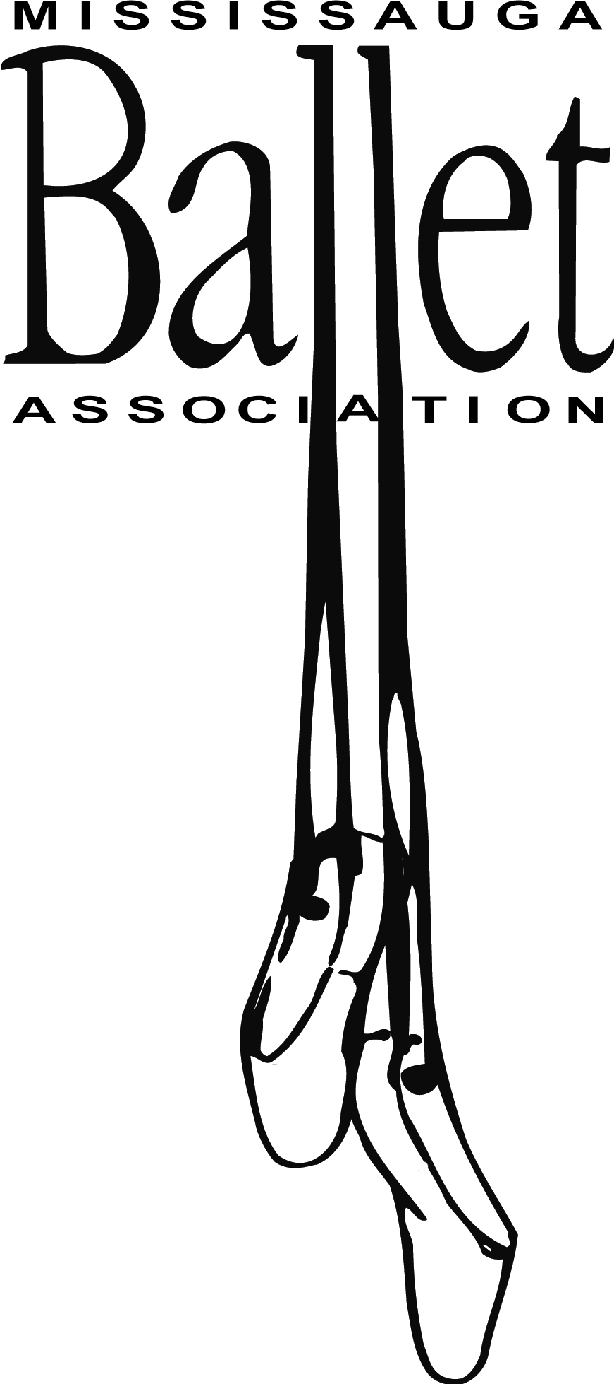
Hoodie Order Form 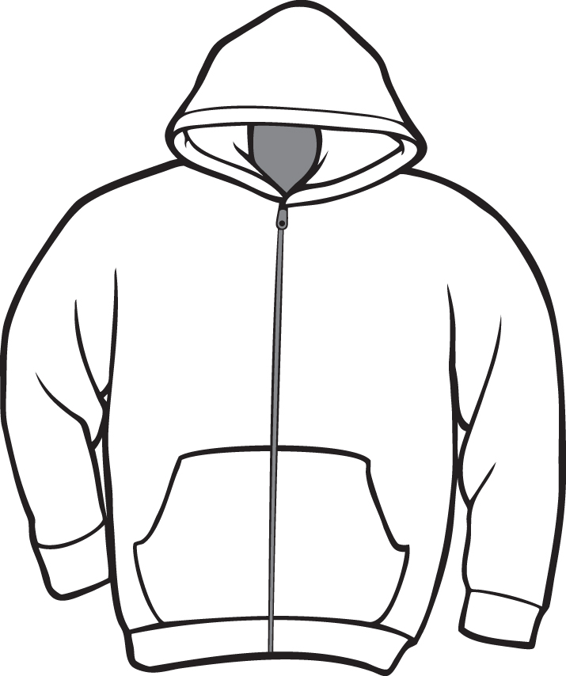

Child’s name ___________________________
Child’s class (day and time) ____________________
Parent’s name and # ___________________________
______________________________
Child’s Black Hoodie $40.00
x-small ___ small ___ med ___ large ___ x-large ___

Adult’s Black Hoodie – $45.00
small___ medium___ large ___ x-large ___

Front of sweat-shirt: logo on left lapel in hot pink
Back of sweat-shirt: “Mississauga Ballet Association” in hot pink

Orders due by Nov. 12 (for delivery before the holidays).
________________________________________________
Amounts include tax. Please provide exact cash (change will not be available) or a cheque made payable to Mississauga Ballet Association.
Total Amount paid _______

